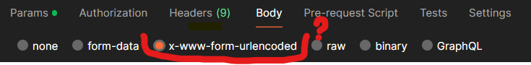

This is one more format that can be used to send the request body along with the API request. It is nothing but key-value pairs that can be sent along with API requests. The main difference is the key and the values are encoded/закодированный.

What does it mean?

It means that key-value pairs separated by ‘&’ ampersand. And between the key and value there is ‘=’ character.

Example:

Key1=Value1&Key2=Value2 ← this format is similar to query parameters.

If in a key or in a value presents not an alphabetic characters, for example : ‘@’, ‘:’, ‘/’, ‘?’, ‘#’, ‘[‘, ‘]’, ‘!’, ‘$’, ‘&’..., they are encoded with percentage encoding, for example:

: %3A

/ %2F

? %3F …

For example:

key 1=valu 1 ←So theris a space in a key and in a value, and the space is not an alphabetic character. It will be encoded and encoding will be applied for space character, encoding for the space character is ‘%20’. The result-

key%201=value%201